A scheme of work For key stage 2 incorporating fairtrade, local history and a major event in the history of britain

Sugar, Slavery and Thomas Fowell Buxton
Contents
About this Educational Pack
- Introduction
- Curriculum Links
- The Thomas Fowell Buxton Society

Lesson Plans
- What is Fairtrade?
- Sugar Cane
- Sugar Cane and the Slave Trade
- Thomas Fowell Buxton and Slavery

Additional Resources
- Image Bank
- Worksheets (Downloadable)
- PowerPoint Slides (Downloadable)

About this Education Pack
This educational pack, sponsored by the Heritage Lottery Fund, has been produced by the Thomas Fowell Buxton Society as part of the society’s work in creating a heritage project that educates people about the contribution of Thomas Fowell Buxton to the history of Britain in the nineteenth century. In particular there is a focus on his contribution to the abolition of slavery throughout the British Empire.
The pack has been developed by Society member, Damian Fannon, Deputy Head Teacher, St Francis RC Primary School, Braintree, Essex. It contains lesson plans and ideas with supporting resources that could be used in an Upper Key Stage 2 classroom. The lesson plans incorporate: the idea of Fairtrade, the production of sugar cane, the slave trade in regard to sugar cane production and the role of Thomas Fowell Buxton in the abolition of slavery. Each lesson plan is supported by PowerPoint slides and, where appropriate, worksheets and factsheets that could be used within the classroom.
Curriculum Links
The content of the lessons link well into the programme of study of the National Curriculum and could also be delivered during Fairtrade Fortnight, which is an annual focus in schools around the United Kingdom.
There are opportunities for the children to consider a key change in the history of Britain, look at maps to develop their understanding of the wider world and a variety of writing activities that meet the criteria of the English curriculum.

The Thomas Fowell Buxton Society
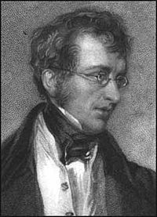
The Thomas Fowell Buxton Society was founded in 2010 to celebrate the achievements of Sir Thomas Fowell Buxton (1786-1845) who, while MP for Weymouth and Melcombe Regis (1818-1837), led the campaign to abolish slavery as an economic system throughout the British Empire. This was achieved by Act of Parliament in 1833.
The society has raised funds and campaigned for a lasting monument to be created to recognise Buxton’s achievements in the town of Weymouth, Dorset. This was finally dedicated on the 5th June 2017 at Bincleaves Green, Weymouth. The society continues to raise awareness of Buxton’s achievements through their ongoing heritage projects
For more information about the work of the society go to www.thomasfowellbuxton.org.uk

What is Fairtrade?
Background Information
Fairtrade Fortnight involves two weeks of every year, the last week in February and the first week in March, devoted to the promotion of Fairtrade products and principles. Fairtrade aims for; “Better prices, decent working conditions, local sustainability and fair terms of trade for farmers and workers in developing countries” (fairtrade.org.uk). Cane Sugar is the product focused on in this study and especially its production in the Caribbean Island of Jamaica.
Tate and Lyle is a well-known brand name for cane sugar on supermarket shelves in the UK. In 2008 the firm signed up to Fairtrade. This means that an agreed minimum price is paid to Fairtrade producers and there is an additional Fairtrade Premium to invest on economic, social and environmental projects in their communities. Workers are guaranteed decent wages and are allowed to join unions and have a democratic say in decision making.
Tate and Lyle’s Fairtrade Promise is printed on their sugar bags:
“When you choose to buy Tate and Lyle Fairtrade cane sugar, you are making a difference to communities around the world. With your help, through the Fairtrade Premium, we support over 20,000 small scale cane farmers in developing countries”.
Jamaica is an island in the Caribbean. The climate is suited to the growth of sugar cane. There are 6 enterprises growing and processing the cane. Worthy Park Cane Farmer Association is made up of a group of small scale cane farmers. The Association was Fairtrade Certified in 2012, after the devastating effects of the tropical hurricane named Sandy. They have a Fairtrade agreement now with Tate and Lyle and the dividend has helped to pay for local projects, even buying donkeys to help with transport.
Adolphus Ward, one of the Worthy Park cane farmers, is nearly 80 and he had only one donkey to transport the cut cane to the mill from his small farm before the cane spoils. In 2014 he applied for the Fairtrade Premium to buy another donkey. Adolphus got two more donkeys and was delighted! (Guardian: Sat 21st February 2015 by Tim Adams).
Resources
- See Image Bank
- PowerPoint Slides
Lesson Structure
Introduce the concept of Fairtrade. What does this mean to the children? Children share their ideas with their talk partners/small groups and feedback to the class.
Display the Fairtrade aims on the IWB. Relate this to Tate and Lyle sugar and show the Fairtrade bags. Draw attention to the Tate and Lyle Fairtrade promise printed on the bags. Is this a good thing? Get the children to discuss and share their ideas.
Show the map of Jamaica on the IWB and explain how the climate is suited to growing sugar cane. Show images of the Worthy Park Cane Sugar Farmers and how Fairtrade has helped to develop their projects.
Show image of Adolphus and explain how Fairtrade was able to help him develop his business.

Key Questions
What are the aims of Fairtrade?
How does Tate and Lyle help the Cane Farmers of Jamaica?
How did the Fairtrade Premium help Adolphus?
Activities
Children write a report answering the key questions above. This could use ICT – either in the form of word processing or creating a video using I-pads to communicate their ideas. Work could then be used to form a webpage based on their work using Google Sites or something similar.
Design a leaflet explaining the importance of Fairtrade, and how it helps people, to promote the Fairtrade principles.
Children retell Adolphus’ story through a storyboard of four pictures or in third person narrative.
Extending Learning
Children could research how the Fairtrade premium helps farmers in other parts of the world such as through the Traidcraft website producer stories.
http://www.traidcraftschools.co.uk/producer-stories

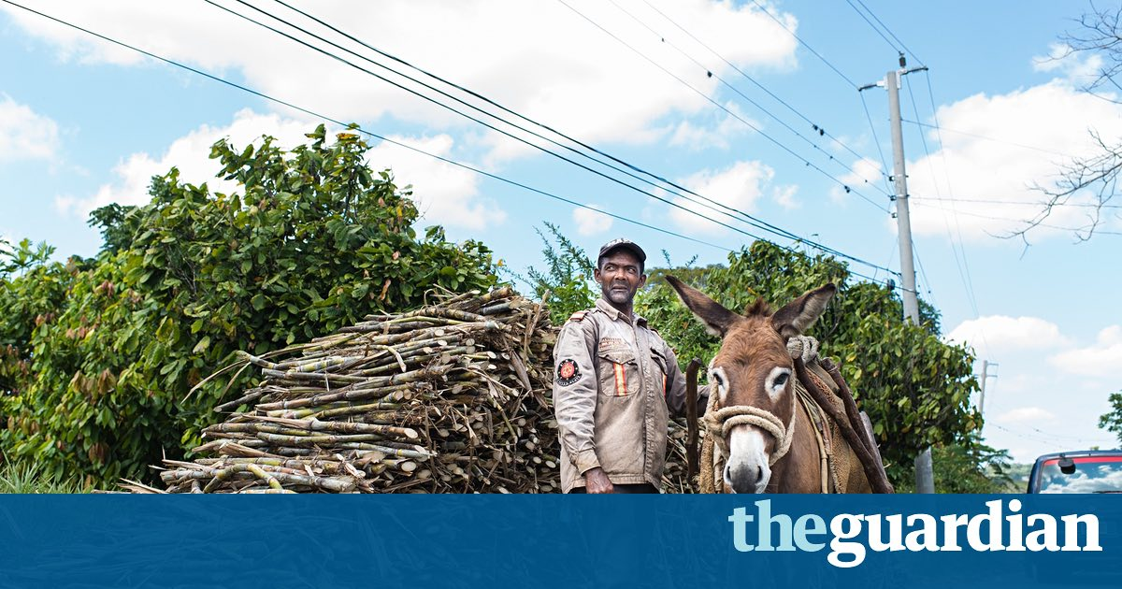
Photograph by O’Brien Brown and reproduced with permission of Fairtrade Foundation.

Sugar Cane
Background Information
Sugar cane is a tall grass native to Southern Asia. It can reach heights of 2m-6m and the stalk can be as thick as 5cms in diameter. The stalks are rich in sucrose. It grows mainly in tropical regions where there is plenty of sunshine and a good supply of water provided either by rainfall or by irrigation.
Originating in India it is now cultivated in over 90 countries though the main producers are Brazil, India, China, Thailand, Pakistan and Mexico. 80% of the sugar used today comes from cane sugar.
Although the sugar cane plant can be grown from seed, most modern cultivation is from stem cuttings. Each cutting has at least one bud. These can be planted either by hand or machine. Hand planting and harvesting characterise the developing world whilst mechanisation characterises the developed countries.
In developing countries the cane is cut just above ground level with cane knives or machetes. In developed countries harvesting is done by machines such as combine harvesters or specialised sugar cane harvesters. Once the harvesting is done, rapid processing in mills is needed to avoid losing the sugar content. Raw sugar from these mills is often exported for further processing in refineries in North America or Europe. Such refineries are often located at major ports as with Tate and Lyle’s refinery in London, UK.
Other products from the raw sugar processing stage include bagasse, molasses, filtercake and ethanol. Ethanol can be used as an alternative to petrol. The residual fibre of the cane can be used in the production of paper and paper products, as well as being burned to provide power to drive the mills. Filtercake is an animal feed. Molasses is a food and is used to produce rum in the Caribbean. (Wikipedia: sugar cane and tasteandsmile.com/our-story)
Resources
- See Image Bank
- PowerPoint Slides
- Worksheet 1 – The Harvesting Process
- Worksheet 2 – Map of the World (colouring)
- Atlases if desired
Lesson Structure
Remind children about the previous lesson about Fairtrade in Jamaica and Adolphus’ story. What can they remember? Children remind their partner about the previous learning.
Can anyone remember what Adolphus was farming? Sugar Cane. Today’s lesson will explore how sugar cane is farmed and processed and the products that it can be used to make.
Show the image of the sugar cane and explain that the sugar is produced in many countries throughout the world. Use the slides to show the process of harvesting and processing before exportation to refineries.
Key Questions
Which countries are the main producers of sugar cane in the world?
How is planting and harvesting different in some areas of the world?

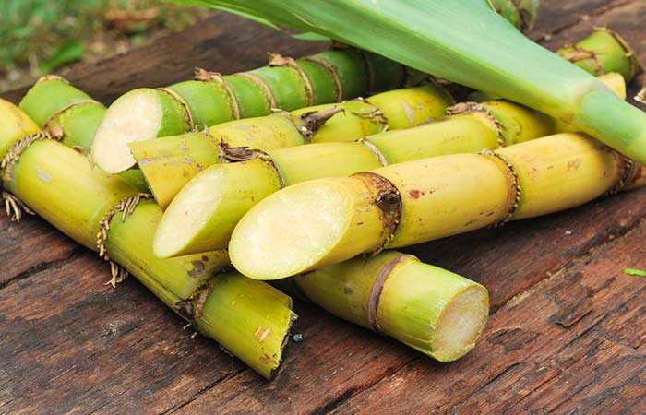
Activities
Children sequence the harvesting process by completing the worksheet in developing countries.
Children identify the main producers of sugar cane on the world map using atlases or the internet to assist them with their research.
Extended Learning
Children use the internet to investigate how other products are farmed, produced and exported. This activity could link to other Fairtrade producers and the journey from field to fork.
http://schools.fairtrade.org.uk/resources/
Sugar Cane and the Slave Trade
Background Information
The Spanish brought the crop to the Americas and Christopher Columbus is credited with introducing it to the Caribbean. Barbados became an English colony in 1624 and Jamaica followed in 1655. Worthy Park Estate in Jamaica has been producing sugar cane since 1670. Colonisation by European countries of the Caribbean islands and a ready demand for sugar back in Europe meant that it was a well-established cash crop by the eighteenth century.
Planting and harvesting by hand and primitive refining methods in boiling houses meant that a large labour supply was needed. Slaves brought from Africa provided the labour. Manufactured goods from Britain were exchanged for slaves in West Africa and the slaves were then transported across the Atlantic Ocean to the Caribbean, where they were sold to plantation owners. Sugar was shipped back to Britain.
This triangular trade meant that slaves endured such cramped conditions on the Middle Passage from Africa to the Caribbean that 1 in 3 died on the journey. They were regarded as commodities not as human beings. On arrival they often met diseases to which they had no immunity and many died. The slave supply wasn’t self-sustaining and so more and more Africans were imported. It was a major migration of African people.
The slaves spent long hours working in the fields or in the mills, enduring high temperatures both inside and outside. They were often treated harshly, especially if they attempted to escape from the plantations. There were slave revolts and these were put down by local militia with resultant hangings and floggings. Things needed to change.
Resources
- See Image Bank
- PowerPoint Presentation
- Worksheet Slaves cutting cane (colouring)
- I-pads for filming if desired
Lesson Structure
Display the word Slavery. What does this word mean to you? Children share their ideas with their partner and feedback to the class. Explain that slavery has been around for thousands of years and that all of the great civilisations that we learn about in history have used slavery as a means of a cheap labour force. What do you think of slavery?
Explain that sugar, as it is today, was very popular and that it was produced in places like the Caribbean in plantations. As the demand for sugar was so great, workers were needed so West African slaves were transported to the plantations in return for goods.
Stress the hardships of the transportation as well as the long hours working in the fields and the mills. Explain that slaves were treated harshly and were whipped or even put to death if they didn’t work hard enough or tried to escape.
You could show Life on a Plantation from the BBC website. It is targeted at KS3 children. http://www.bbc.co.uk/education/clips/zn64q6f
What is your opinion on the treatment of the slaves? Share with partner and ideas shared.
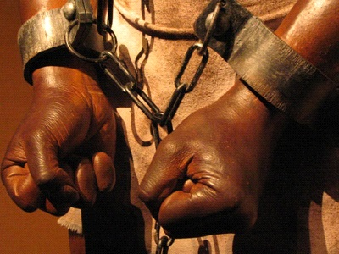
Key Questions
What is slavery?
Why were slaves transported to the Caribbean?
What was the life of a slave working on the plantation like?
Activities
Children write an explanation of what slavery is and how and why slaves were used in the sugar industry. They should use the key questions to help to scaffold their writing.
Children work in groups to present a short drama about slavery in the sugar plantations. The children would need a narrator to tell the story whilst others act out the story. The short dramas could be videoed, edited and displayed.
Children write a diary entry of a day in the life of a plantation slave. They should focus on the hardships and look to develop the skill of empathy.
Extended Learning
More information on slavery and life in the plantations can be found through the BBC KS3 Bitesize website. This offers the opportunity to explore this topic in greater detail and has a wide variety of video clips available to use in the classroom.

Thomas Fowell Buxton and Slavery
Background Information
One hero who played an important part in changing things was Thomas Fowell Buxton, MP for Weymouth and Melcombe Regis, 1818-1837. He was born in Essex, not Dorset. His grandmother, Sarah Buxton had a house in Wyke Regis, Weymouth, called Belfield House. Thomas Fowell Buxton visited the house regularly as he was growing up and met King George III there on one occasion. Another time he nearly drowned rowing in Weymouth Bay with his younger brother, Edward North Buxton.
He went to school in London and was so tall that he was nicknamed “The Elephant”. He went on to Trinity College University in Dublin, Ireland, and after gaining his degree he returned to England to marry Hannah Gurney in 1807.
1807 was an important year as William Wilberforce, MP for Hull in Yorkshire, pushed through a Bill in Parliament for the Abolition of the Slave Trade. This did not mean the end of slavery, for babies were still born into slavery on the plantations in the Caribbean, on islands such as Jamaica.
Thomas Fowell Buxton entered Parliament as MP for Weymouth and Melcombe Regis in 1818. He had inherited Belfield House in 1814 on the death of his grandmother. He rented it to his Uncle Charles who lived there for many years.
In Parliament, Thomas Fowell Buxton was interested in prison reform and criminal law reform. There were 230 crimes that could merit the death penalty; this was successfully reduced to 8. His sister-in-law was Elizabeth Fry, who was important in prison reform. Buxton went with her on visits to Newgate Prison in London and he wrote a book on prison reform.
William Wilberforce persuaded Buxton to take over leading the abolitionists in Parliament to try to end slavery throughout the British Empire. This was a hard task to undertake but Buxton and fellow abolitionist MPs succeeded in 1833 when slavery as an economic system was abolished. It came into force a year later.
As a reward for all his hard work he was made a Baronet in 1840, Sir Thomas Fowell Buxton of Belfield in the County of Dorset and Runton in the County of Norfolk. His motto was “Whatever your hand findeth to do, do it with thy might”.
The Buxton Monument erected on Bincleaves Green in Weymouth was dedicated to his memory in 2017. The stones were hand-carved by students of Weymouth College Masonry Department and the design was by a student, Peter Loizou.
In London there is a statue of him in Westminster Abbey and an ornate fountain dedicated to him is in the nearby Victoria Tower Gardens. In Norwich, Norfolk, there is a remembrance plaque to him in the Cathedral. In Freetown, Sierra Leone, West Africa, there is a bust of him in St George’s Cathedral. In Ontario Canada there is a settlement bearing his name. In Guyana, mainland South America, there is a village, ten miles from the capital Georgetown that bears Buxton’s name. He is remembered too at the Mico University in Jamaica. He is of importance internationally and nationally, as well as being part of our local Weymouth heritage.

Resources
- See Image Bank
- Worksheet – Design your own Monument
- Factsheet
- PowerPoint Presentation
Lesson Structure
Recap previous lesson, remembering the conditions and treatment of slaves on the sugar plantations. What do you think should be done to help them? Children discuss and share their ideas.
Discuss the word ‘hero’. What is a hero? What sort of things makes someone a hero? Children discuss and share their ideas. Collate a list of attributes.
Explain the role of Thomas Fowell Buxton in the movement to abolish slavery. How do you think the slaves would have felt upon hearing the news that slavery was abolished?
Use the slides (or factsheet) to learn more about the life of Thomas Fowell Buxton.
Key Questions
What did Thomas Fowell Buxton do that was heroic?
How did the end of slavery in the British Empire help people?
What can you remember about the life of Thomas Fowell Buxton?
Activities
Children write a biography of Thomas Fowell Buxton using the information from the factsheet and PowerPoint presentation. The images sheet will give them pictures that could be used in their work.
Design your own monument for either Thomas Fowell Buxton or your own personal hero.
Children write about their own hero. What did they do that makes them heroic?
Extended Learning
Plan a visit to the Buxton Monument on Bincleaves Green, Weymouth. Sketch the monument, particularly focusing on the carvings.
More information is available http://www.thomasfowellbuxton.org.uk/
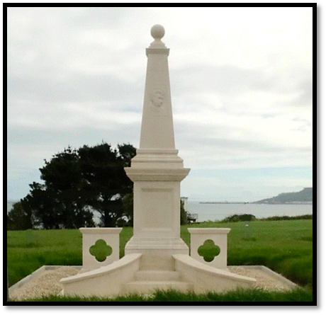
The Buxton Monument on Bincleaves Green, Weymouth, Dorset.

Image Bank
What is Fairtrade?
- Tate and Lyle Sugar Bag
- Adolphus and his donkey
- Map of Jamaica
Sugar Cane
- Cut Sugar Cane
- Sugar Cane Growing in the Field
Sugar Cane and the Slave Trade
- Slave Ship
- Manacles
- Map of Jamaica
Thomas Fowell Buxton and Slavery
- Thomas Fowell Buxton Portrait
- Buxton Monument, Weymouth
- Belfield House, Weymouth

List of Worksheets
- World Map – Identifying the 10 largest producers of sugar cane
- Harvesting the Sugar Cane
- Colouring Sheet – Cutting Cane on a Plantation
- Design Your Own Monument
- Thomas Fowell Buxton Factsheet
All worksheets are available as a download from the Thomas Fowell Buxton Society website.
www.thomasfowellbuxton.org.uk
Acknowledgements
The photograph of Adolphus and his Donkey is by O’Brien Brown and it is reproduced by kind permission of the Fairtrade Foundation.
The photograph of The Buxton Monument is by John Fannon and is reproduced by kind permission of the Thomas Fowell Buxton Society.
The Thomas Fowell Buxton Society believes that the images accompanying these lessons are licence and royalty free. However, if any owner or licensor disagrees, please contact the Society via its website: www.thomasfowellbuxton.org.uk
