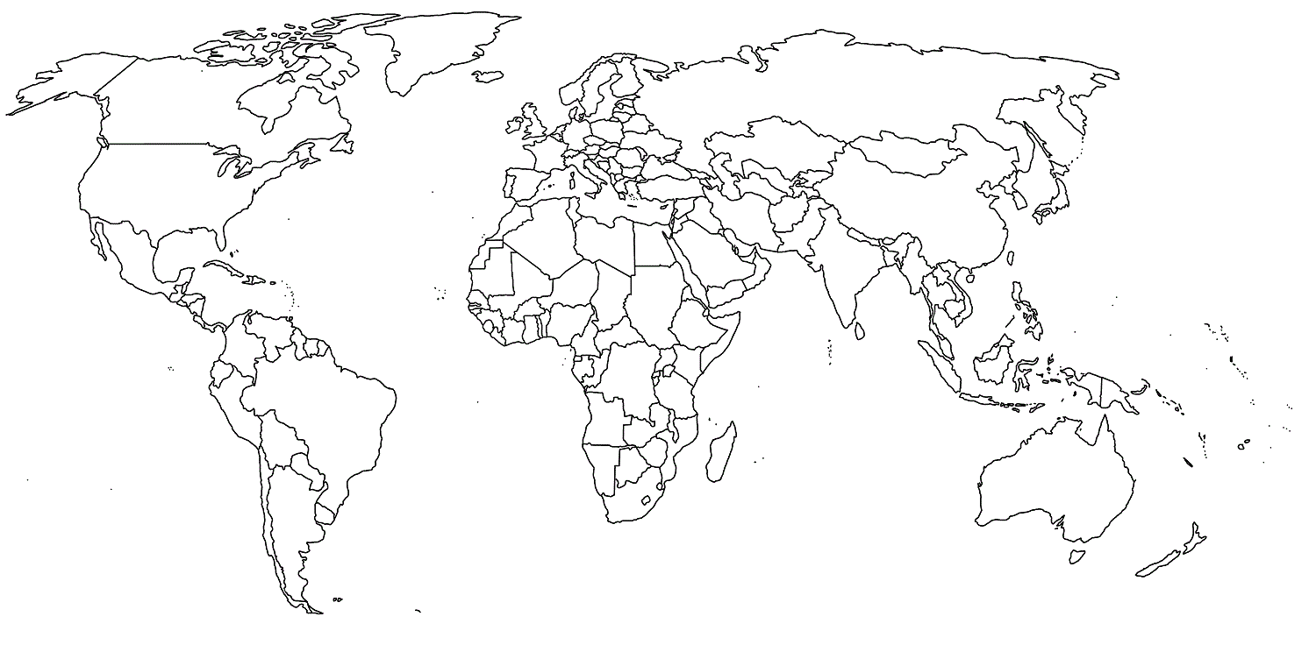
Can you colour the top ten Sugar Cane producing countries?
Brazil | India | China | Thailand | Pakistan
Mexico | Colombia | Indonesia | Philippines | USA

