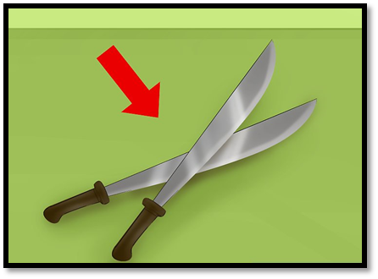
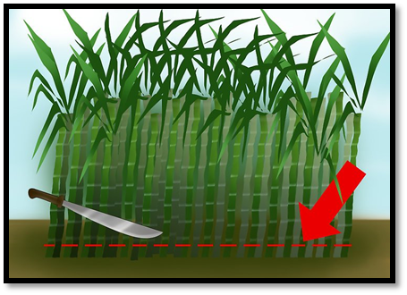
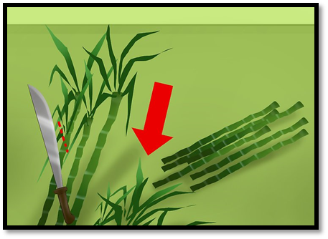
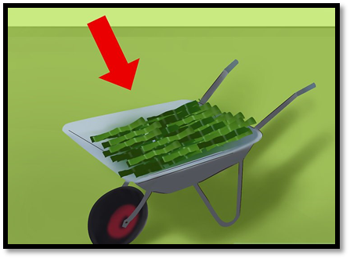
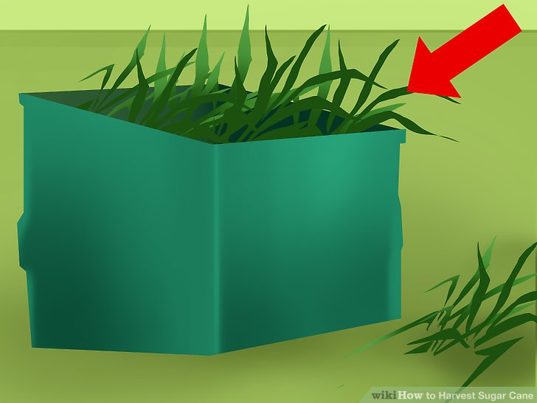
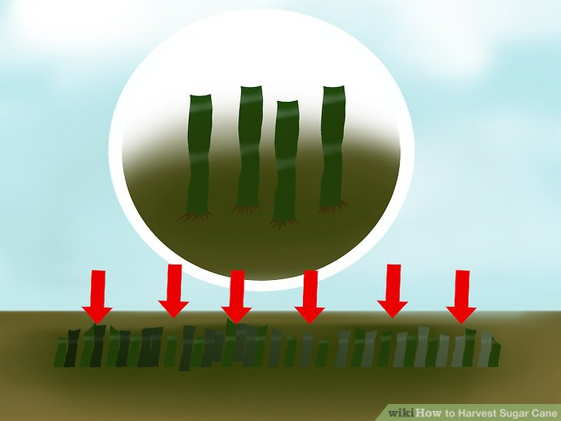

Using the pictures above, can you create an information text explaining how sugar cane is harvested?
You can write short descriptions of each of the stages and stick the pictures into your book to create a well-presented piece of work. Alternatively, you could draw your own pictures to accompany your writing.

